|  |  |  |  |  |  |
| --- | --- | --- | --- | --- | --- |
| Date | 10-Dec-22 | | | Tester Name | Mohammad Yusuf |
| Environment | Penfax - Test | | | Login used |  |
| Operating System | Windows | Version: | Update: | | |
| Software Used | Edge | Version: | Update: | | |
| Not Applicable | Version: | Update: | | |
| Release version |  | | | | |
| Title | E7 Fund Transfers | | | | |
| Test Type | Regression | | | | |
| Test Scenario | E7.07 Asset Rebalance from same fund 100% to same fund | | | | |
|  |  | | | | |
| Expected Results | Asset Rebalance should not saved as 100% transfer from 1 fund to the same fund is not allowed. | | | | |
| Pass/Fail |  | | | JIRA# | N/A |

Describe your steps with screenshots:

1. Search active PEPP member. Click on Stakeholder ID.

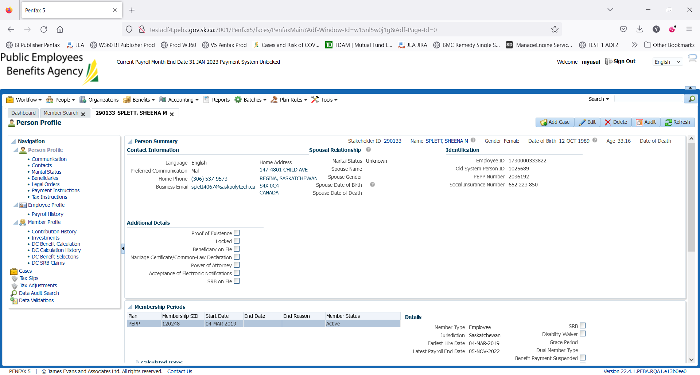

1. Click on Investments on the Navigation panel.

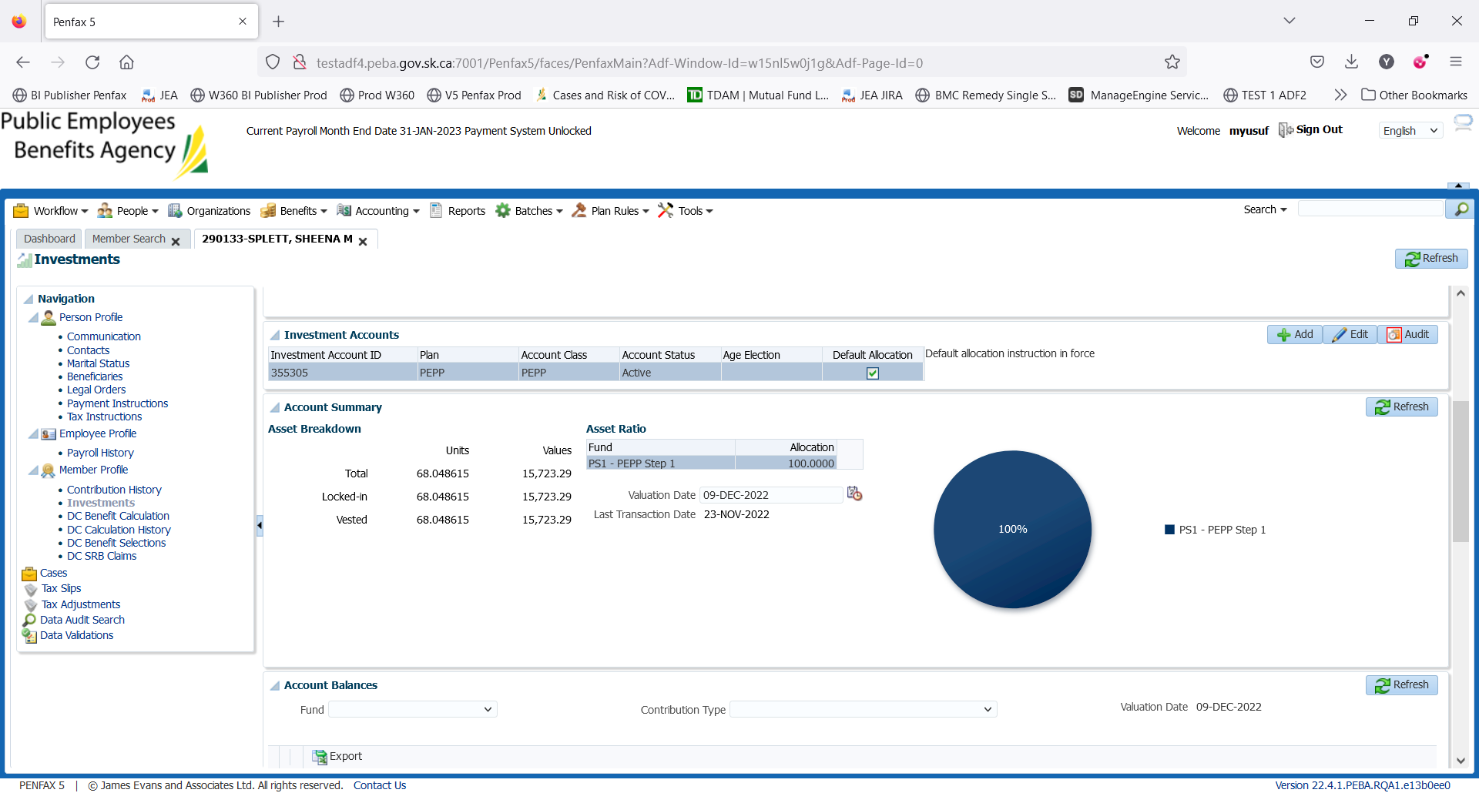

1. Scroll down and open up the Account Instructions Tab. Take note of what the current instructions are. Here, the current deposit allocation is 100% in PS1.

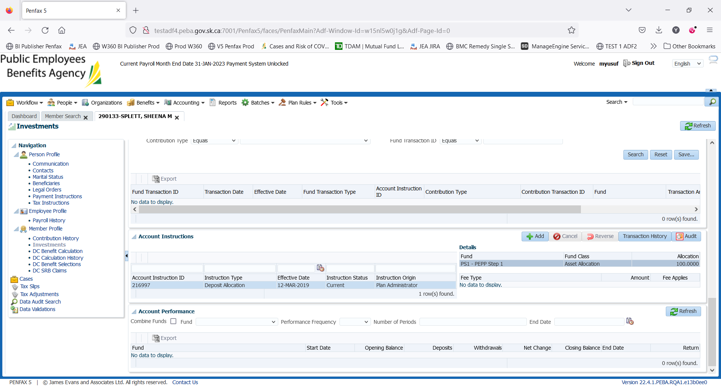

1. Click Add.

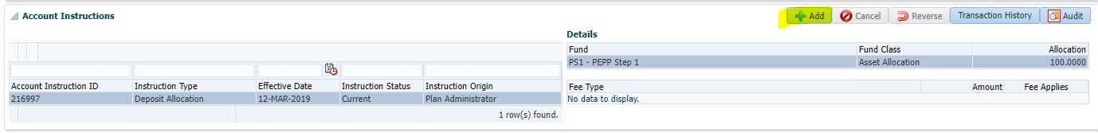

1. Under Instruction Type select Asset Rebalance. Leave Effective Date and Fee Applies as they are. Click Add and select the same fund from the dropdown. Input 100% allocation. Click Save.

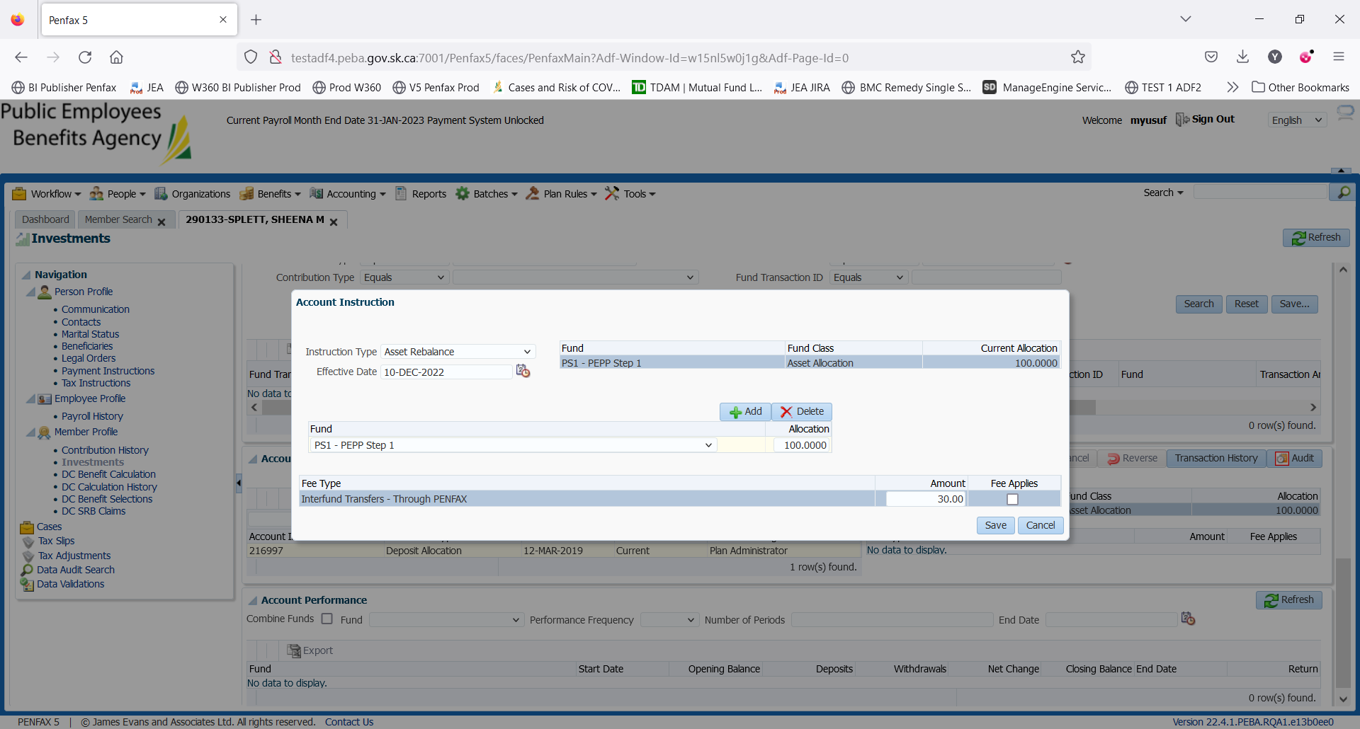

1. Validation error is triggered which is expected.

